Test Case: tc002_SPX_Dev5_Validar_Filtro_Campo_URLPath_Administrador_Roles_Menu
Step 1 - Enter username and password and click to button Enter : Credentials Entered
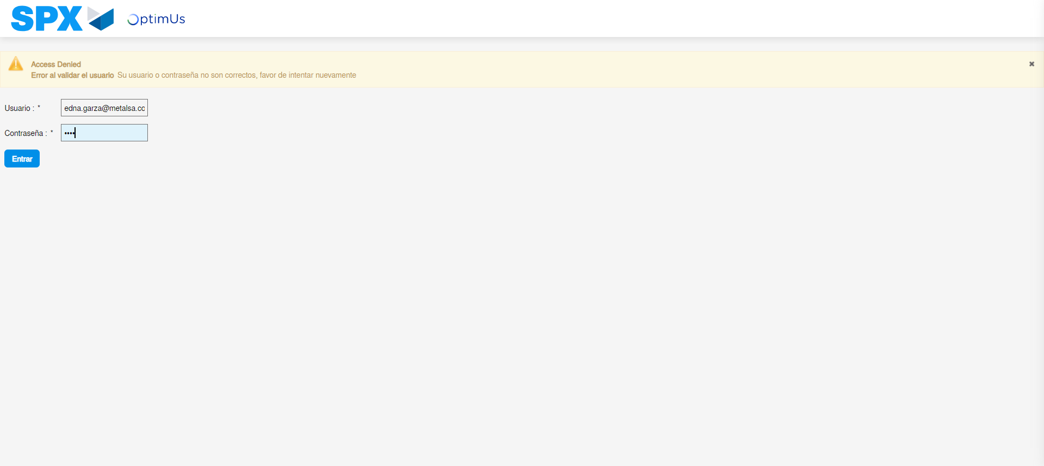Image file-name: QC_Testing-tc002_SPX_Dev5_Validar_Filtro_Campo_URLPath_Administrador_Roles_Menu-may. 15 2024, 12 57 57 p. m.

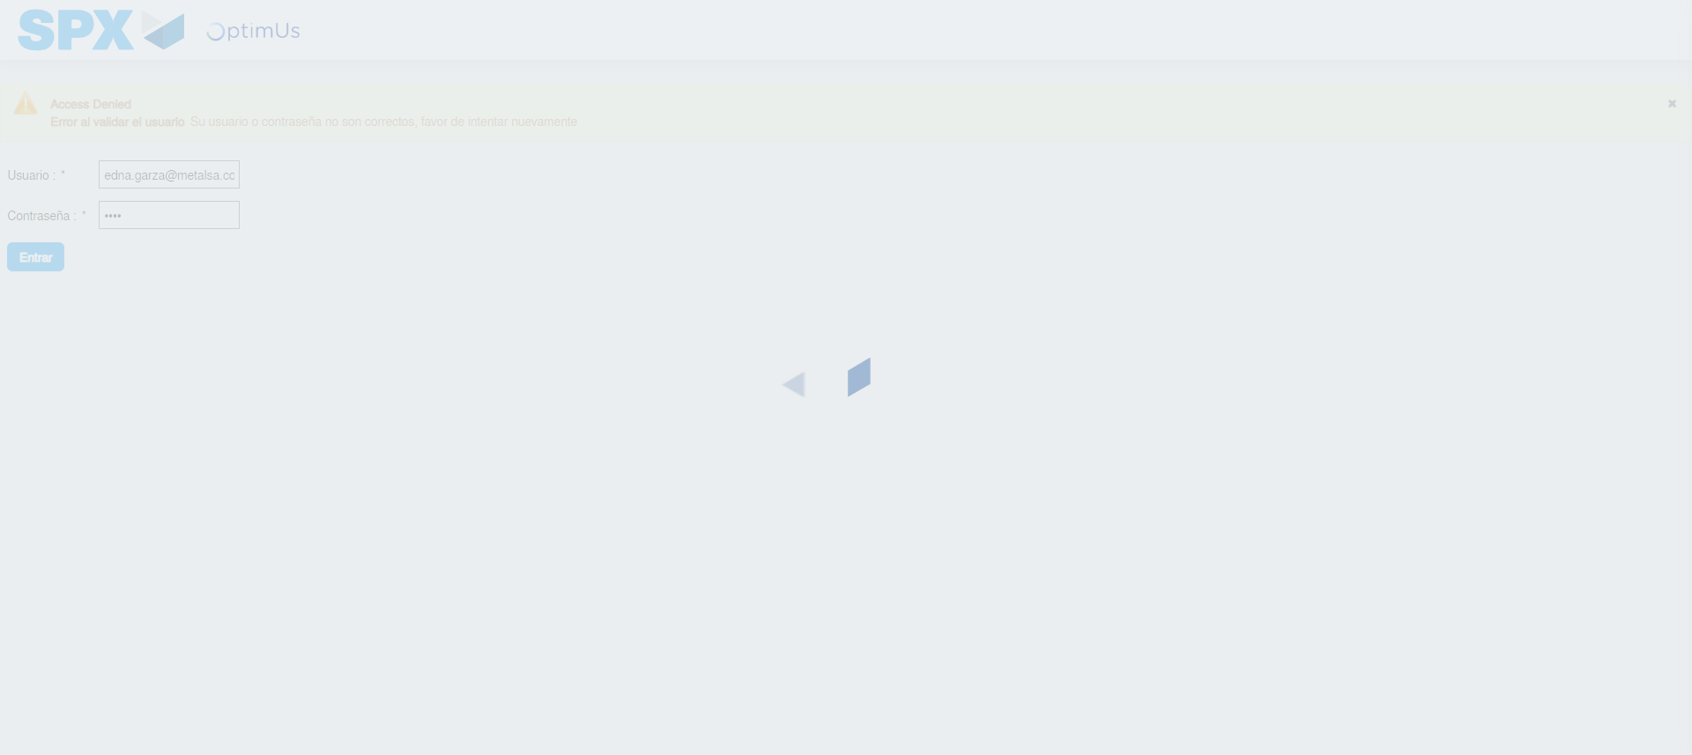Image file-name: QC_Testing-tc002_SPX_Dev5_Validar_Filtro_Campo_URLPath_Administrador_Roles_Menu-may. 15 2024, 12 57 58 p. m.

Step 2 - Select to UEN and Access to Administrador Roles Menu: UEN Correctly selected and Correct access
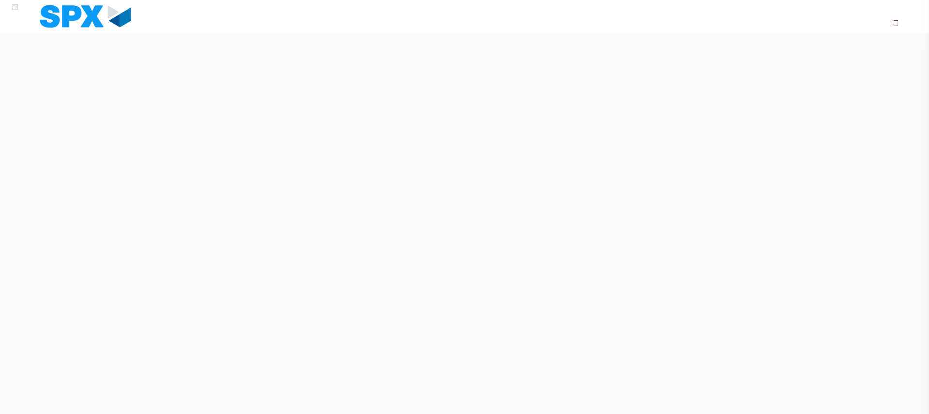Image file-name: QC_Testing-tc002_SPX_Dev5_Validar_Filtro_Campo_URLPath_Administrador_Roles_Menu-may. 15 2024, 12 58 04 p. m.

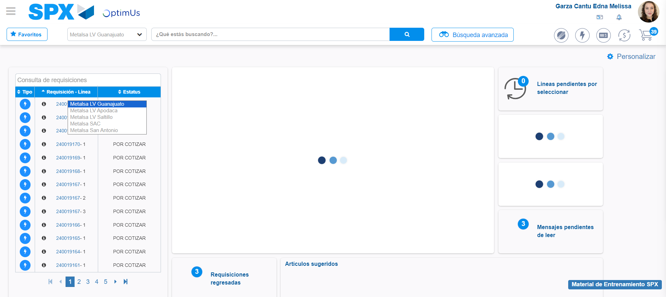Image file-name: QC_Testing-tc002_SPX_Dev5_Validar_Filtro_Campo_URLPath_Administrador_Roles_Menu-may. 15 2024, 12 58 05 p. m.

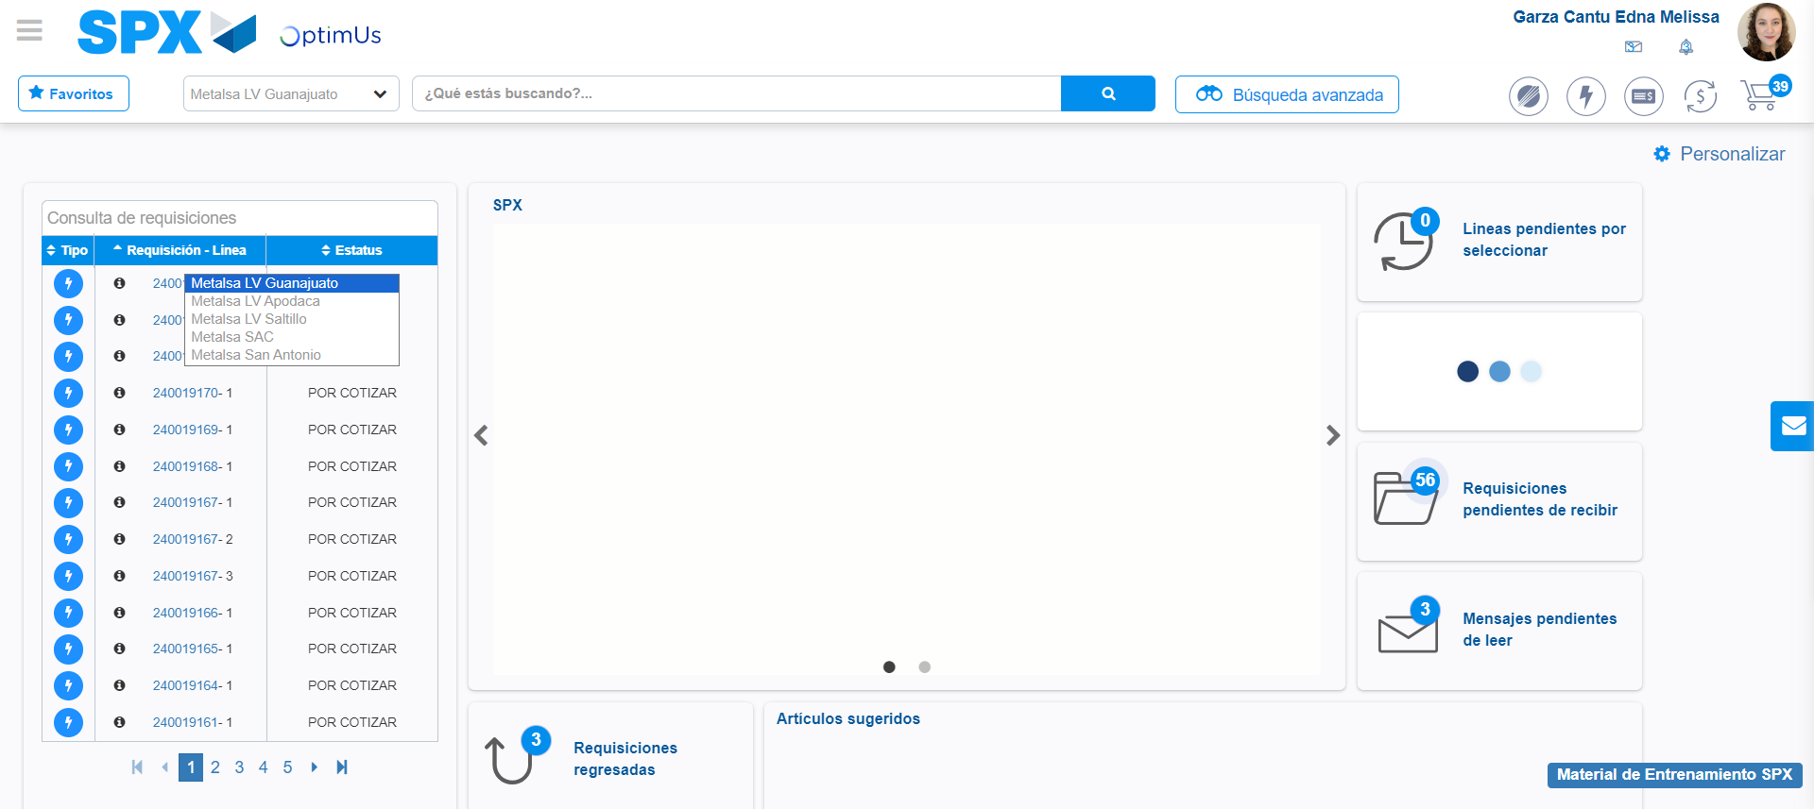Image file-name: QC_Testing-tc002_SPX_Dev5_Validar_Filtro_Campo_URLPath_Administrador_Roles_Menu-may. 15 2024, 12 58 06 p. m.

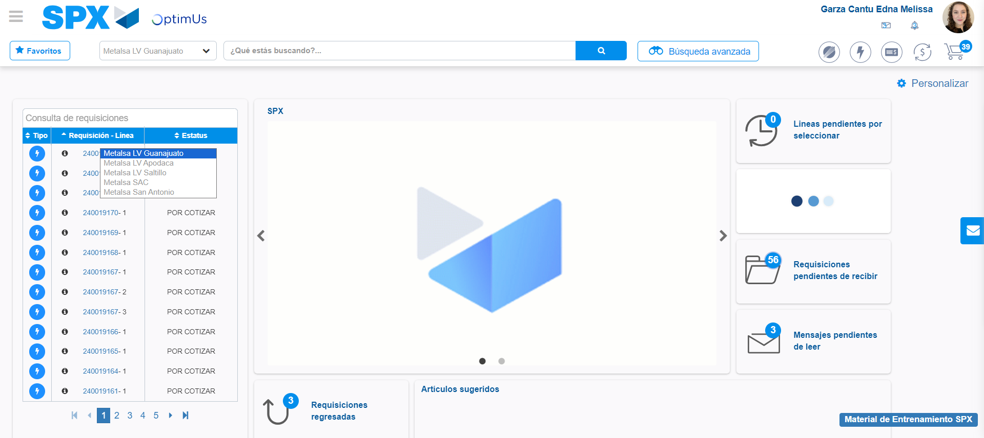Image file-name: QC_Testing-tc002_SPX_Dev5_Validar_Filtro_Campo_URLPath_Administrador_Roles_Menu-may. 15 2024, 12 58 07 p. m.

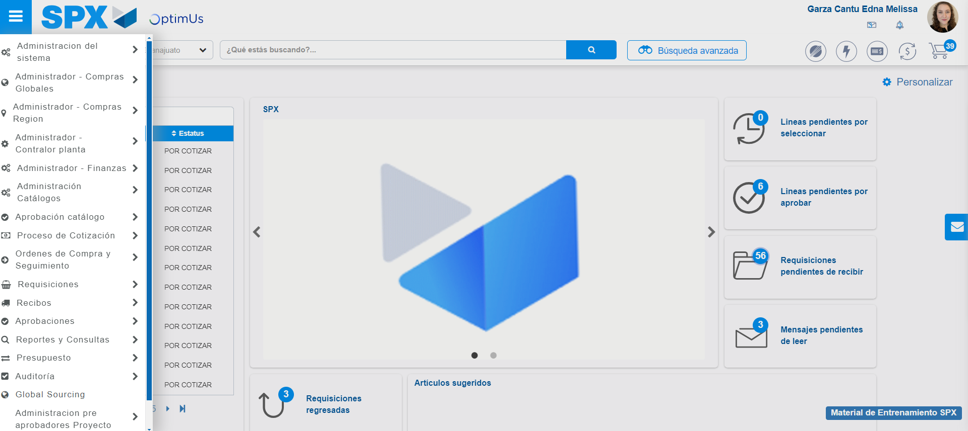Image file-name: QC_Testing-tc002_SPX_Dev5_Validar_Filtro_Campo_URLPath_Administrador_Roles_Menu-may. 15 2024, 12 58 08 p. m.

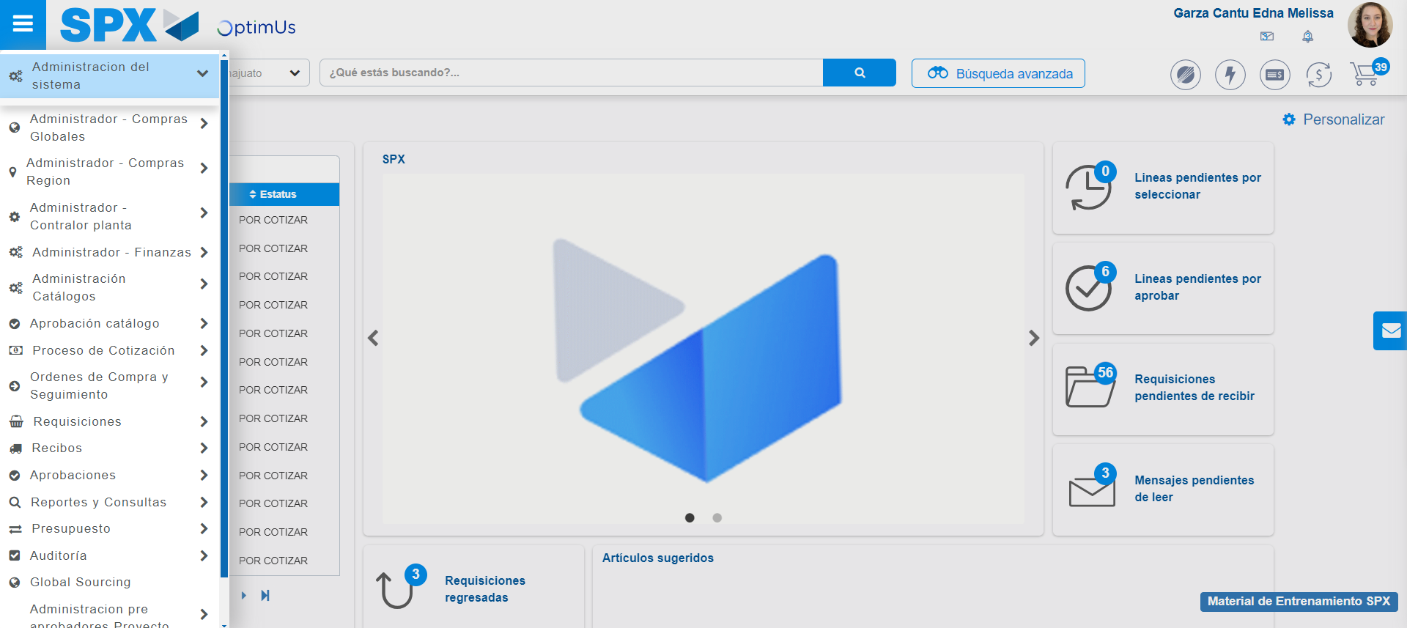Image file-name: QC_Testing-tc002_SPX_Dev5_Validar_Filtro_Campo_URLPath_Administrador_Roles_Menu-may. 15 2024, 12 58 09 p. m.

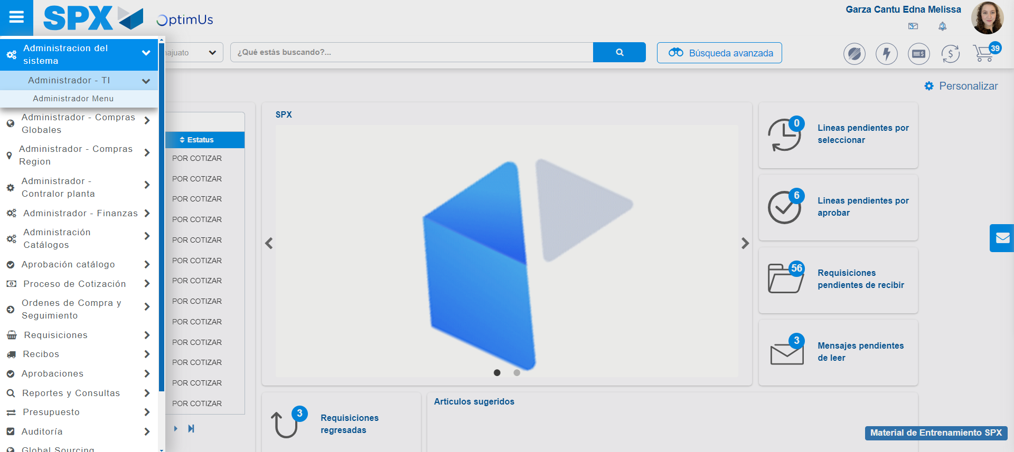Image file-name: QC_Testing-tc002_SPX_Dev5_Validar_Filtro_Campo_URLPath_Administrador_Roles_Menu-may. 15 2024, 12 58 10 p. m.

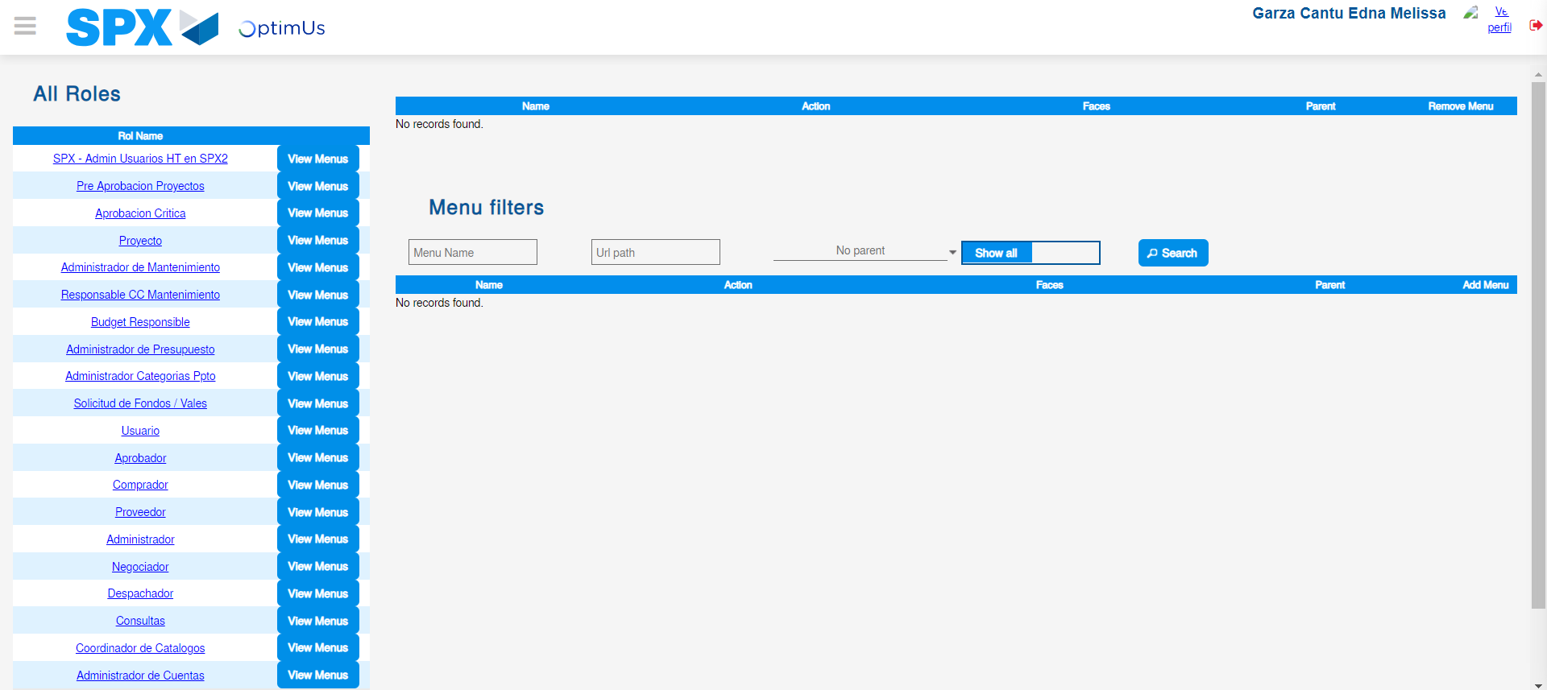Image file-name: QC_Testing-tc002_SPX_Dev5_Validar_Filtro_Campo_URLPath_Administrador_Roles_Menu-may. 15 2024, 12 58 13 p. m.

Image file-name: QC_Testing-tc002_SPX_Dev5_Validar_Filtro_Campo_URLPath_Administrador_Roles_Menu-may. 15 2024, 12 58 14 p. m.

Step 3 - Click to Buttons View Menu and Search Filter with Menu Name: Correct Search
Image file-name: QC_Testing-tc002_SPX_Dev5_Validar_Filtro_Campo_URLPath_Administrador_Roles_Menu-may. 15 2024, 12 58 14 p. m.

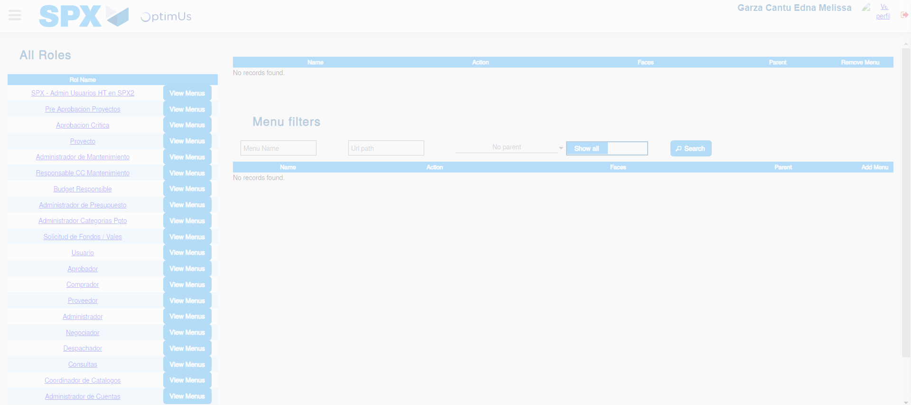Image file-name: QC_Testing-tc002_SPX_Dev5_Validar_Filtro_Campo_URLPath_Administrador_Roles_Menu-may. 15 2024, 12 58 15 p. m.

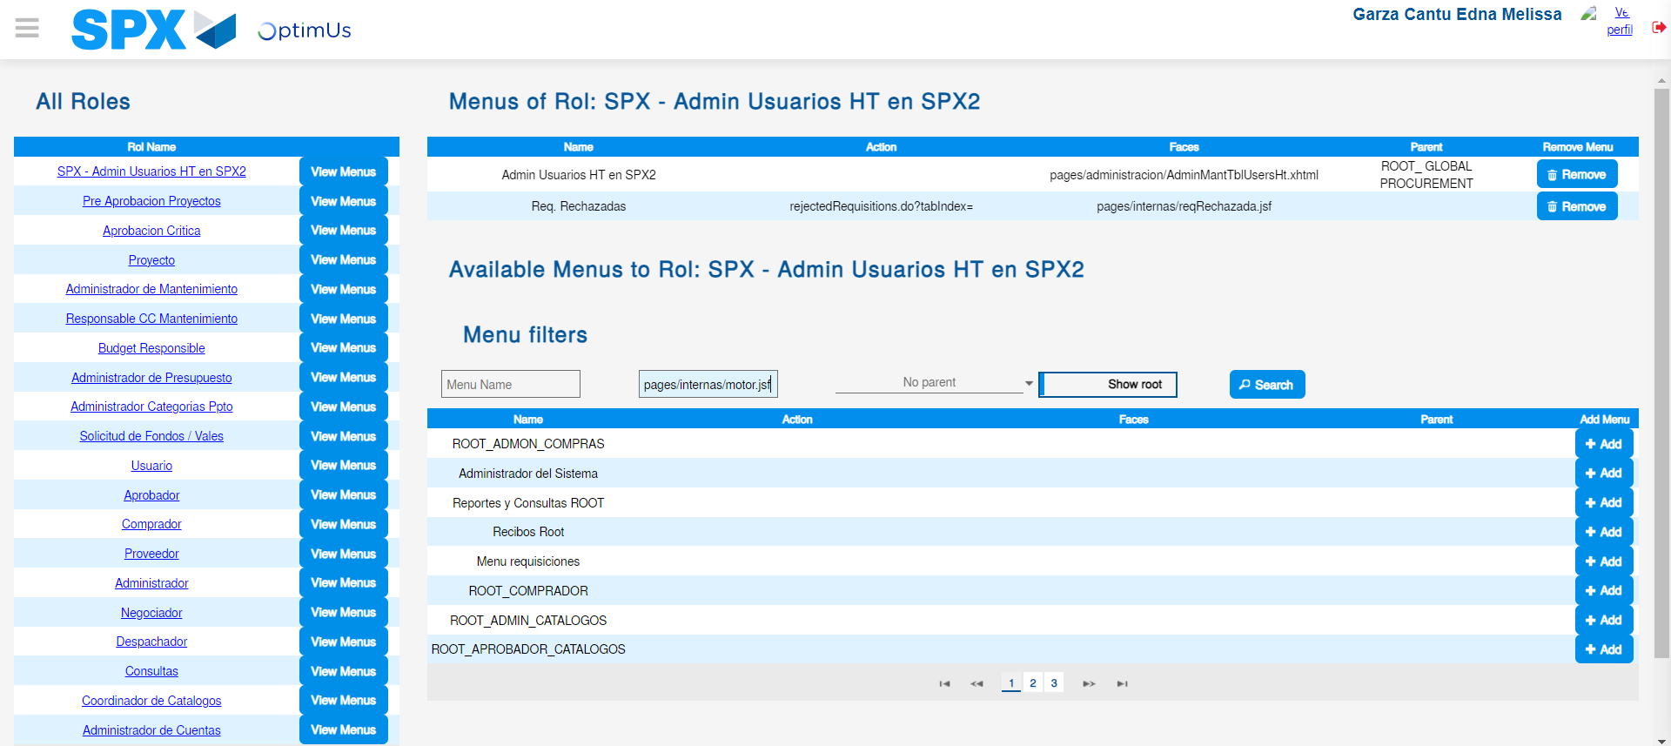Image file-name: QC_Testing-tc002_SPX_Dev5_Validar_Filtro_Campo_URLPath_Administrador_Roles_Menu-may. 15 2024, 12 58 16 p. m.

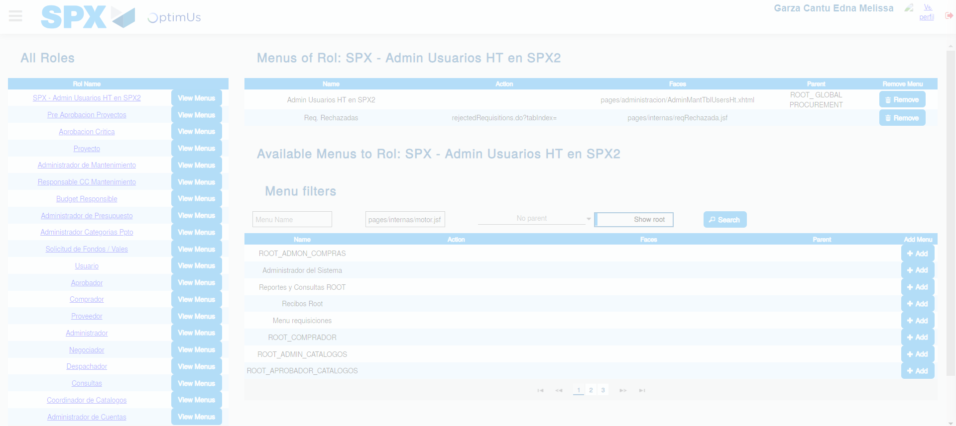Image file-name: QC_Testing-tc002_SPX_Dev5_Validar_Filtro_Campo_URLPath_Administrador_Roles_Menu-may. 15 2024, 12 58 17 p. m.

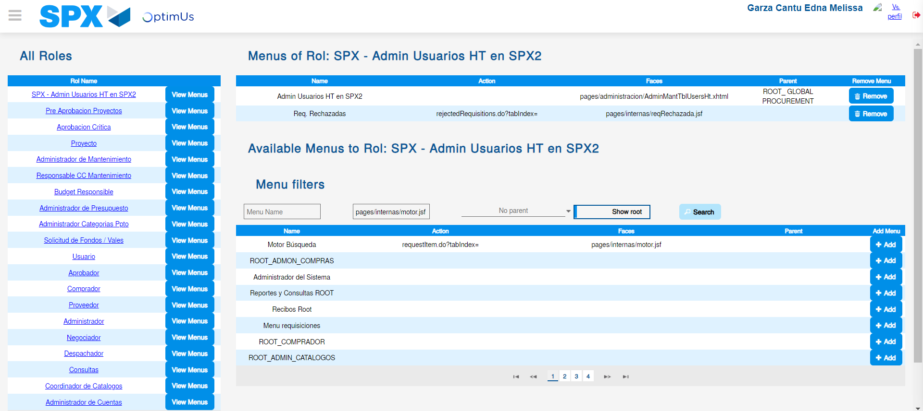Image file-name: QC_Testing-tc002_SPX_Dev5_Validar_Filtro_Campo_URLPath_Administrador_Roles_Menu-may. 15 2024, 12 58 18 p. m.

